APPLECROSS SENIOR HIGH SCHOOL

YEAR 11 HUMAN BIOLOGY
TEST 1

DO NOT MARK THIS PAPER IS ANY WAY

Time allowed: 50 minutes Total marks: /50

PART A: Multiple Choice (20 marks)

- Mitochondria concentration would be highest in which of these cells?

- Nerve cells
- Secretory cells
- Muscle cells
- Red blood cells

- What organelle would you expect to be abundant in enzyme secreting cells:

- Lysosome
- Chloroplast
- Nucleolus
- Golgi apparatus

- When viewing cells under the microscope, which of the following is false?

- The higher the magnification, the less cells you see
- When the slide is moved to the right, it appears to move to the left
- Under lower magnification you would see more of the cells in the field of view
- When changing the magnification from 40X to 100X, the field of view is greater

- A series of interconnecting canals transporting fluids has been observed in the cell. These canals are called:

- Mitochondria
- Endoplasmic reticulum
- Centrioles
- Lysosomes

- If a mixture of proteins and glucose is placed in a cellulose bag immersed in water, the glucose will diffuse through the bag but the proteins will not. This is because the bag is:

- A living membrane
- Selectively permeable
- Permeable only to molecule of inorganic origin
- Impermeable to all except large organic molecules

- Cells take in water through their cell membranes by the process called:

- Respiration
- Facilitated diffusion
- Cytoplasmic streaming
- Osmosis

- The concentration gradient of carbon dioxide in a muscle cell is found to be greater after exercise than before. This would cause:

- The passive movement of carbon dioxide out of the cell
- The passive movement of carbon dioxide into the cell
- The active movement of carbon dioxide out of the cell
- The active movement of carbon dioxide into the cell

- In the plasma membrane ______________ makes the membrane more flexible:

- Proteins
- Phospholipids
- Cholesterol
- Glycolipids

- Which statement is false:

- Tissues are made up of cells
- The skin is an organ
- Organs are made up of tissues
- Each organ is made up of its own kind of tissue

- Which of the following statements about cells and surface area are correct?

- Increasing the diameter of a cell increases the surface area more than the volume
- Increasing the diameter of a cell increases the volume more than the surface area
- Increasing the diameter of a cell increases the volume but decreases the surface area
- Increasing the diameter of a cell increases its surface area but decreases its volume
- Which of the following is the best definition of osmosis?

- Movement of molecules from regions of high concentration to regions of low concentration
- Movement of molecules from regions of low concentration to regions of high concentration
- Net movement of water molecules across a differentially permeable membrane
- Random movement of molecules or ions in solution

- Skin is considered an organ because:

- It consists of tissues structurally joined together to perform a specific function
- It is large and covers the entire body
- It is compact to give shape
- It is continuous

- The concentration of a particular ion within a cell is higher than the concentration outside the cell. However, the concentration in the cell is still increasing. This is due to:

- Osmosis
- Diffusion
- Active transport
- Facilitated diffusion

- Four microscopes were set up in the laboratory as follows:

Microscope | Objective Lens | Ocular
A | 10X | 5X
B | 20X | 10X
C | 40X | 5X
D | 40X | 10X

When looking at a slide of human tissue, which microscope would you expect to observe the fewest cells?

- A
- B
- C
- D

- Oxygen always moves across the plasma membrane by the process of:

- Active diffusion
- Facilitated diffusion
- Osmosis
- Simple diffusion
Refer to the illustration to answer questions 16 and 17.
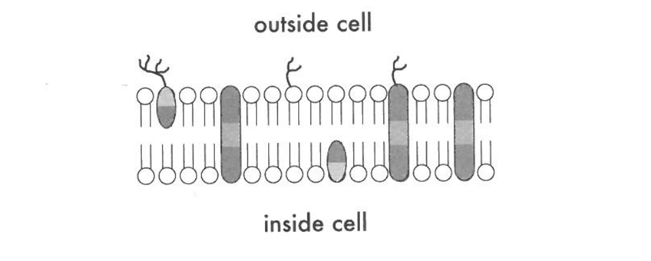
A
B
C

D
E

F

- Which molecule may function in facilitated diffusion?

- A
- B
- D
- E

- Which molecule is both hydrophobic and hydrophilic and aggregates as a bilayer to form the “fabric” of the membrane?

- C
- D
- E
- F

- Extracellular fluid contains approximately 10 times more sodium ions compared to intracellular fluid. This is possible through the process of:

- Facilitated diffusion
- Osmosis
- Exocytosis
- Active Transport

- If a blood cell is placed in pure water, it will die because:

- Water diffusing in will cause it to burst
- Water diffusing out will dehydrate it
- Carbon dioxide will be unable to diffuse out
- Cell organelles will diffuse through the membrane

- The solvent that is usually associated with osmotic pressure is:

- Alcohol
- Fats
- Oxygen
- Water

YEAR 11 HUMAN BIOLOGY – TEST 1
Name:
Score: /30

PART B: Short answer questions (30 marks)

The diagram below illustrates two processes carried out by a cell.

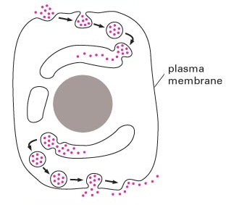
A
B

- State the names of the two processes A and B illustrated and provide an example of what is transported this way.
(4 marks)
  - .

Example:

Example:

- Describe what is meant by the term fluid mosaic model.
(2 marks)

- Use the diagram below to complete the table.
(6 marks)
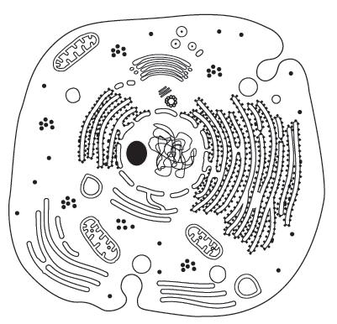
A
B
C
D

Structure Label | Cell Organelle Name  (¹/₂ mark each) | Function  (1 mark each)
A

B
(small dots)
C

D

- A semi-permeable membrane allows materials to be transported through it in several ways.
- What are the differences between passive and active transport?
(2 marks)

- Describe one type of each active and passive transport, and provide an example of what is transported in each process.
(4 marks)

- Complete the table by naming the four types of tissues, describing the function of each tissue type and providing a specific example of each tissue type. (8 marks)

Tissue Name | Function | A specific example
Muscular Tissue

Connective Tissue

Epithelial Tissue

Nervous Tissue

- If the field of view is 0.4mm, calculate the length and breadth of cell A in micrometres.
All working out must be shown to be awarded full marks.
(4 marks)
